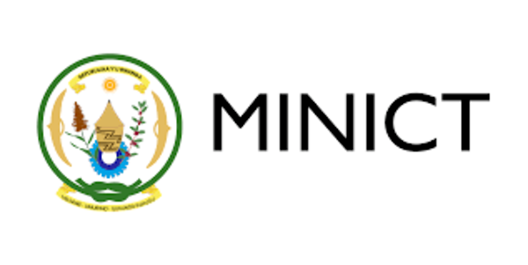



Capacity Development Workshop on

**Digital Government and National   
Data Governance Framework in Rwanda**

22-23 March 2023  
Kigali, Rwanda

Concept Note

**1. Background**

The world is entering the digital age that is now unleashing unfathomable opportunities for sustainable development. The COVID-19 pandemic also revealed the vitality of digital government and digital solutions to address isolation and keep people informed and engaged. Given that there are both immense opportunities and inherent risks on what digital transformation can bring about, the need to address emerging requirements, risks and challenges for digital public policies and to ensure inclusive multistakeholder engagement has become more critical, especially for countries with special needs, including the least developed countries (LDCs), small island developing States (SIDS), the landlocked developing countries (LLDC), and countries with transition economics.

The world is also moving closer to becoming a truly digital society. At the global level, the quantity of data is expected to increase more than fivefold from 33 zettabytes in 2018 to 175 zettabytes in 2025, with 49 per cent stored in the public cloud. But at the same, the various digital divides between and within developed and developing countries continues to widen, which is inhibiting developing countries from contributing to and benefiting from integration into the global economy. Governments are among the largest producers and consumers of data in many countries, and they also play a critical role in data regulation. Much of the operational activity in government is now data-driven, making it difficult, if not impossible, to function effectively without data. However, many developing countries lack the institutional capacity to fully implement data management frameworks and data strategy, impeding them to fully reap the benefits of data governance.

As a flagship research and capacity development tool of the United Nations Department of Economic and Social Affairs (UN DESA), the UN E-Government Survey evaluates how digital government can facilitate integrated policies and services across 193 UN Member States. The Survey supports countries’ efforts to provide effective, accountable and inclusive digital services to all, bridge the digital divide and leave no one behind. The Survey measures e-government effectiveness in the delivery of public services, providing a snapshot of relative measurement of e-government development of all Member States.

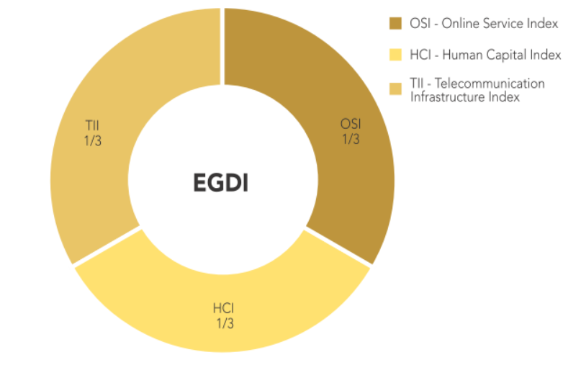

Methodologically, the EGDI is the weighted average of normalized scores on the three most important dimensions of e government, namely: (i) the scope and quality of online services quantified as the Online Service Index (OSI); (ii) the status of the development of telecommunication infrastructure or the Telecommunication Infrastructure Index (TII); and (iii) the inherent human capital or the Human Capital Index (HCI). Each of these indices is a

composite measure that can be extracted and analysed independently.

In addition, UN DESA has also has conceived the project supported by the UN Peace and Development Fund, entitled “Developing institutional capacities for digital data management and cooperation to advance progress toward the Sustainable Development Goals”, to support developing countries to assess key data management and governance challenges and strengthen government officials’ and stakeholders’ knowledge of sound and secure data management. This project seeks to address existing challenges and gaps in digital data management and cooperation, focusing on enhancing the institutional capacities of countries to utilize, manage and govern data in a comprehensive, objective and evidence-based manner, through regional and global cooperation.

Under the research framework established by UN DESA, data governance is supported b the three principles of Sustainable Goal 16 (accountability, effectiveness and inclusiveness) and examined through the lens of the four pillars (policy, institutions, people, and process) and six elements (see following illustration)[1]. This allows for a comprehensive and holistic examination of the various procedural components which together enable effective, accountable, and inclusive data governance.

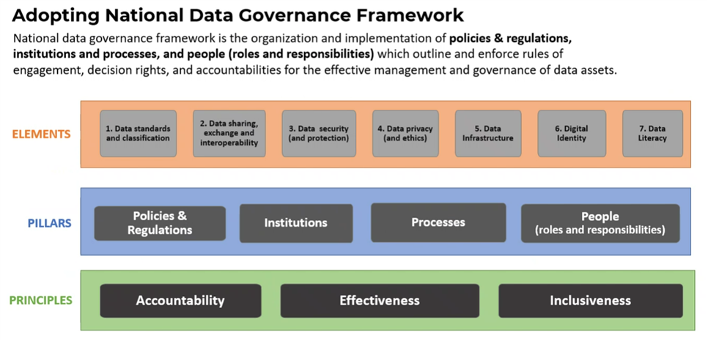

*Development in Rwanda*

In Rwanda, public institutions offer 98 online services. The significant increase in national investment in online services provision has allowed the country to become a leader among the LDCs and to compete with the world’s leading countries in e-government development.

Aiming to address challenges and improve user-centricity in services provision, Rwanda is focusing on collecting real-time information for internal and strategic public planning, to guide decision-making processes, and to inform the development of targeted solutions. The country uses real-time specific, measurable, attainable, relevant and time-bound (SMART) analytics to track services delivery performance, including through heat maps and location-referenced quick performance reviews of public entities such as schools, hospitals and farming areas. The Government is strengthening inter-agency data sharing to facilitate problem solving and policy alignment and is taking steps to reduce costs, to improve the quality of existing services or develop new ones, to prevent, detect and mitigate errors, to decrease corruption, and to foster innovation with an eye to anticipating future trends. With financing from the World Bank Group and through collaboration with the private sector, Rwanda has launched several digital inclusion initiatives to help 250,000 households acquire digital devices and to provide 3 million people with the opportunity to improve their digital literacy. As part of its ICT for Governance cluster Strategy 2020-2024, Rwanda is planning to further expand inclusive digital services and ICT-enabled empowerment[2].

The success enjoyed by Rwanda in e-government development derives from a long-term vision that was initiated in 2000 and realized in 2020 with the SMART Rwanda Master Plan. The strategy and its focus on digital transformation are intended to contribute to the attainment of the SDGs, in particular Goal 9. Besides significantly increasing access to ICT and striving to provide universal and affordable access to the Internet, the Government has expanded investment to facilitate sustainable infrastructure development and support domestic technology development. By 2024, the Government is committed to making its services available online 24 hours a day and making all citizens and residents digitally literate regardless of their socio-economic or political status[3].

Challenges in e-government remain in different forms and scales. For instance, in a research study undertaken in Rwanda, official estimates indicate that 1 in 5 (or 20 per cent) of the country’s residents are using the Internet, but the numbers for meaningful connectivity (such as the use of e-service) are as low as 1 in 160 (just over 0.6 per cent)[4].

In view of the above, UN DESA in collaboration with the Ministry of ICT and Innovation, Government of Rwanda, supported by the Tony Blair Institute, will be hosting a two-day capacity development workshop with representatives from governments, private, public sector, civil societies, academia and other key stakeholders, on the subject of digital government and data governance.

The Workshop will provide a timely opportunity to engage government officials and other stakeholders, focussing on digital government, data and data governance with the objective of strengthening the capacity of public sector employees in the concerned governmental organizations with regards to understanding of how to improve the performance of digital government and strategize related initiatives.

**2. Objectives of the Workshop**

The objective of the National Consultation Workshop is three-fold, as follow:

* Build capacities in understanding and implementing UN DESA’s e-government development framework, guided by the UN E-Government Development Index (EGDI)
* Engage stakeholders from different agencies and other non-government stakeholders in the official dialogue and knowledge exchange on digital government and national data governance framework for Rwanda
* Explore the existing opportunity and gap assessments for proposed focus areas, emerging from dialogue and interaction among workshop participants, including the proposed UN DESA data governance framework of 4 pillars and 6 elements
* identify the next course of action in strategic planning and implementation for advancing digital government and setting up a national data governance framework

**3. Thematic Areas and Guiding Questions**

A. The primary thematic areas of the EGDI (Day 1)

* The EGDI framework
* The three components of EGDI (OSI, TII and HCI)
* The five categories of OSI (Institution framework (IF); data/content provision (DP); service provision (SP); e-participation (EPI); technology (TEC)
* Other complementary indices: (i) Open Government Development Index (OGDI; (ii) Local Online Service Index (LOSI)

B. The primary thematic areas of the National Data Governance (Day 2)

Four (4) pillars of National Data Governance:

* Policy: existing policy and regulatory framework;
* Institutions: existing institutional framework
* People: existing data ecosystem and mapping of stakeholders
* Processes: existing data processes

Six (6) elements of National Data Governance

* Data standards and classification
* Data sharing, exchange and interoperability, including open government data
* Data security (and data protection)
* Data privacy (and ethics)
* National data infrastructure (including e.g., datacenter, cloud, data services, etc.)
* Linking data governance to digital identity)

**4. Expected Outcomes**

The following are the expected outcomes of the Workshop:

* To build institutional and individual capacities, with participants get insight on issues of national data governance (for government data)
* To build a shared understanding on issues of the data governance in the public sector
* To identify the strengths and weakness of the existing national data governance
* To identify the next course of actions and potential interventions with a proposed timeline

The outputs of each of the sessions and a follow up action plan will be captured in the summary report. A policy brief may be issued by UN DESA in consultation with the Ministry of ICT and Innovation, Government of Rwanda.

**5. Date and Venue**

Date/time: **22-23 March 2022**

Venue: Venue: **Kigali Convention Center**

**\* Wednesday 22 March 2023 – Room AD 10**

**\* Thursday 23 March 2023 – Room MH4**

(lunch and coffee breaks will be provided at the Workshop venue)

Number of participants: **45**   
(Note: by invitation only; including organizers, resource persons and support staff)

**6. Participants**

It is expected that the participants for the workshop to include:

* Senior government officials
* Non-governmental experts from the private sector, civil society, think tanks, academia, with knowledge and experiment in national data governance frameworks
* Experts from other countries
* Staff representatives from UN Resident Coordinators’ Office and other related UN agencies
* Experts and staff members from UN DESA and Government of Rwanda

Following ministries and agencies (but not limited to) are invited:

1. Ministry of ICT and Innovation
2. Rwanda Information Society Authority
3. Rwanda Utilisation Regulatory Authority
4. Local Government Officials
5. Data protection office

**7. Languages**

The Workshop will be conducted in English.

**8. Surveys and evaluation**

Pre-workshop surveys and post-workshop evaluations will be circulated. A follow-up questionnaire could be sent out to participants after the Workshop.

**9. Organizers and Facilitators**

The Workshop is jointly organized by the Division of Public Institution and Digital Government (DPIDG) of UN DESA and the Ministry of Information Communication Technology and Innovation, Government of Rwanda.

For any question, please contact:

UN DESA:

Wai Min Kwok ([kwok@un.org](mailto:kwok@un.org))

Rachael Purcell ([purcell@un.org](mailto:purcell@un.org))

MINICT:

Waleed Ali [wali@minict.gov.rw](mailto:wali@minict.gov.rw)

Calvin Ganza [cganza@minict.gov.rw](mailto:cganza@minict.gov.rw)

Alex Muriuki (a.muriuki@institute.global)

1. United Nations (2020), United Nations E-Government Survey 2020: Digital Government in the Decade of Action for Sustainable Development, UN DESA, p. 166.
2. Source: (UN E-Government Survey 2022 P21)
3. Source: UN E-Government Survey 2022 P65
4. Source: UN E-government Survey 2022 P129