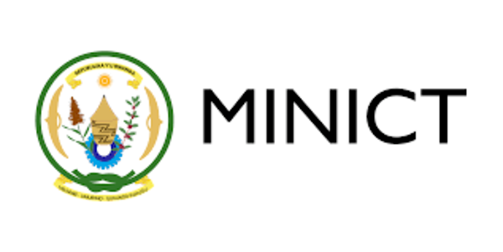



Capacity Development Workshop on

**Digital Government and National Data Governance Framework in Rwanda**

Agenda   
22-23 March, 2023   
  
Venue: Kigali Convention Center   
* Wednesday 22 March 2023 – Room AD 10  
* Thursday 23 March 2023 – Room MH4

| **Day 1** | |
| --- | --- |
| 09:00 AM - 09:30 AM | **Registration** |
| 09:30 AM - 10:00 AM | **Opening Session**  *Speakers:*  ***Yves Iradukunda, Permanent Secretary,*** *Ministry of Information Communication Technology and Innovation, Rwanda* ***Juwang Zhu****, Director, Division for Public Institutions and Digital Government (DPIDG), UN DESA (5 min)*  ***Chad Bond,*** *Global Sector Head, EGovernment, Tony Blair Institute (5 min)*  *Moderator: Alice Higiro* ***Group Photo Opportunity*** |
| 10:00 AM - 10:15 AM | **Setting the Scene**  Explain the agenda, define the workshop thematic areas and expected outcomes ***Wai Min Kwok****, Senior Governance and Public Administration Officer, UN DESA; International Consultant, UN DESA*  *DG Gordon - MINICT   Tony Sebera - RISA*  *Leila Rwagasana - Irembo*  *Moderator: Alice Higiro* |
| 10:15 AM - 10:30 PM | **Tea/Coffee Break** |
| 10:30 AM - 11:30 AM | **Session 1: UN E-Government Development Index (EGDI)**  Presentation:   **UN DESA E-Governmemt Development Index (EGDI) Framework  - EGDI and its three components (OSI, TII and HCI)**  ***Wai Min Kwok,*** *Senior Governance and Public Administration Officer, DPIDG, UN DESA*  Initiate open discourse and answer participant questions  *Moderator: Alice Higiro* |
| 11:30 AM - 1:00 PM | **Session 2: Online Service Index and its five categories**   * The five categories of OSI  - (Institution framework (IF);  - data/content provision (DP);  - service provision (SP);  - e-participation (EPI);  - technology (TEC) * Complementary indices: (i) E-Participation Index (EPI) (ii) Open Government Development Index (OGDI; (iii) Local Online Service Index (LOSI)   Presentation:  ***Wai Min Kwok,*** *Senior Governance and Public Administration Officer, DPIDG, UN DESA*  Initiate open discourse and answer participant questions  *Moderator: Alice Higiro* |
| 1:00 PM - 2:00 PM | **Lunch** |
| 2:00 PM - 3:00 PM | **Session 3: Case studies**  Presentation: **Case study I - UK**   ***Chad Bond,*** *Global Sector Head, EGovernment, Tony Blair Institute (5 min)*  Initiate open discourse and answer participant questions  *Moderator: Alice Higiro* |
| 3:00 PM - 3:30 PM | **Tea/Coffee Break** |
| 3:30 PM - 4:30 PM | **Session 3: Case studies**  Presentation: **Case study II - Shanghai**  Mobile government and mobile governance  ***Zheng Lei***, Fudan University  Initiate open discourse and answer participant questions  *Moderator: Alice Higiro* |
| 4:30 PM - 5:00 PM | **Day 1 Closing** Summarize Day 1 and brief Day 2 Agenda  ***Wai Min Kwok,*** *UN DESA*  ***DG Gordon*** *- MINICT* |

| **Day 2** | |
| --- | --- |
| 09:00 AM - 09:30 AM | **Morning tea and networking** |
| 09:30 AM - 10:30 AM | **Session 4: National Data Governance Framework**  Presentation: **“UN DESA Data Government Framework”**  ***Wai Min Kwok,*** *UN DESA*  Case sharing - **Data Governance** ***Zheng Lei***, Fudan University  Case sharing - **Data Governance in Rwanda *Gloria Ingabire***, RISA  *Case Sharing -* ***Data-driven and AI-enabled services*****Audace Niyonkuru***, Digital Umuganda*  Initiate open discourse and answer participant questions  *Moderators: Alice Higiro* |
| 10:30 AM - 10:45 AM | **Tea/Coffee Break** |
| 10:45 AM - 1:00 PM | **Session 5: Breakout Focus-Group Discussion**  (10 -15 participants in each group[1])  **Focus Group 1**: Online services, data standards, design standards and interoperability  **Focus Group 2:** Digital government, data security, personal privacy and ethics  ***Wai Min Kwok,*** *UN DESA* |
| 1:00 PM - 2:00 PM | **Lunch** |
| 2:00 PM - 4:00 PM | **Session 5: Interactive Sessions (continued)**  **Reporting back at Plenary Session** Presentation on the key discussion outcomes  Interactive Discussion  *Moderators: Wai Min Kwok, UN DESA* |
| 4:00 PM - 4:30 PM | **Tea/Coffee Break** |
| 4:30 PM - 5:00 PM | **Closing session (the way forward)**  ***Wai Min Kwok,*** *UN DESA*  ***Chad Bond****, TNI*  ***DG Gordon*** *- MINICT* |

1. Each group comprises participants from Government, private sector, academia, civil society and regional governments.