FACT SHEET
On the findings of the 2020 E-Government Survey for the Caribbean region
Prepared by the United Nations Department of Economic and Social Affairs (UNDESA)
Division for Public Institutions and Digital Government
Date 10 August 2020

Background
- The UN E-government Survey tracks progress of e-government development through the E-Government Development Index (EGDI). The EGDI is a composite index that comprises three normalized indices: (i) Telecommunications Infrastructure Index (TII), based on ITU data; (ii) Human Capital Index (HCI) based on UNESCO data; and (iii) Online Service Index (OSI) based on data collected by DESA, which assesses the e-government development of UN Member States. The Online Service Index is also complemented by the Member State Questionnaire (MSQ), a voluntary survey conducted by UN DESA.
- A country’s relative position in the e-government development rankings may fluctuate over time owing to global changes and to changes in national development and rankings of other countries. While individual country performance still matters, it is more useful to interpret the values and rankings based on the movement of countries between the four EGDI groups, and rating class within its EGDI group.
- The overall 2020 ranking is finalized in late 2019; data from ITU and UNESCO were also collected in 2019. It means that further digital development initiatives implemented after those dates would not be reflected in the 2020 Survey.
- In 2020, for the first time, the ranking is supplemented by the rating class—further analysis of countries grouped according to four equally defined intervals (quartiles) within every value group to gain better insight into countries with similar levels of performance in each of the EGDI groups.
- The Survey no longer emphasizes the global top 20 countries; instead, it assesses the grouping of countries by EGDI level. In this regard, for policy making purposes, it is important to pay attention to the country’s group change in EGDI level rather than relative ranking position among 193 countries.
- The Survey is a mapping and development tool, and DESA encourages countries to exchange policy experience and learn from one another, for those countries with low EGDI to benefit from those with High EGDI; and not to over-emphasize on rankings.
- The link to E-Government Survey 2020 can be found of UNDESA/DPIDG website (here).
ECLAC and Caribbean region
The 33 countries of Latin America and the Caribbean, together with several Asian, European and North American nations that have historical, economic and cultural ties with the region, comprise the 46 Member States of ECLAC. Fourteen non-independent territories in the Caribbean are Associate Members of the Commission. The UN Member States that are also members of CARICOM comprise Antigua and Barbuda, Bahamas, Barbados, Belize, Cuba, Dominica, Dominican Republic, Grenada, Guyana, Haiti, Jamaica, Saint Kitts and Nevis, Saint Lucia, Saint Vincent and the Grenadines, Suriname, and Trinidad and Tobago.
Table 1 below presents the EGDI and its sub-components OSI, HCI, and TII for these 16 UN Member States in the Caribbean, Central and South America that has been assessed for e-government development during the 2020 Survey.
Table 1. EGDI and component indices for the UN Member states of the Caribbean region, 2020
Country | Rating  class | EGDI  Rank | Sub-Region | OSI  value | HCI  value | TII  value | EGDI  (2020) | EGDI  (2018)
Antigua and Barbuda | H2 | 98 | Caribbean | 0.4471 | 0.7518 | 0.6176 | 0.6055 | 0.7229
Bahamas | HV | 73 | Caribbean | 0.6765 | 0.7546 | 0.6739 | 0.7017 | 0.6552
Barbados | HV | 62 | Caribbean | 0.5765 | 0.8549 | 0.7523 | 0.7279 | 0.644
Belize | MH | 136 | Central America | 0.2647 | 0.6919 | 0.4079 | 0.4548 | 0.5726
Cuba | MH | 140 | Caribbean | 0.2588 | 0.8215 | 0.2514 | 0.4439 | 0.6554
Dominica | H2 | 99 | Caribbean | 0.4471 | 0.6698 | 0.6871 | 0.6013 | 0.5906
Dominican Republic | H3 | 82 | Caribbean | 0.7647 | 0.7419 | 0.5279 | 0.6782 | 0.5794
Grenada | H2 | 102 | Caribbean | 0.3412 | 0.8576 | 0.5449 | 0.5812 | 0.593
Guyana | MH | 129 | South America | 0.4647 | 0.6462 | 0.3619 | 0.4909 | 0.5306
Haiti | M1 | 180 | Caribbean | 0.1882 | 0.3839 | 0.2449 | 0.2723 | 0.4660
Jamaica | H1 | 114 | Caribbean | 0.3882 | 0.7142 | 0.5151 | 0.5392 | 0.4697
Saint Kitts and Nevis | H2 | 95 | Caribbean | 0.3941 | 0.8035 | 0.7080 | 0.6352 | 0.4773
Saint Lucia | H1 | 112 | Caribbean | 0.3824 | 0.7205 | 0.5302 | 0.5444 | 0.4316
Saint Vincent and the Grenadines | H2 | 109 | Caribbean | 0.4706 | 0.7214 | 0.4894 | 0.5605 | 0.4115
Suriname | H1 | 122 | South America | 0.2882 | 0.7098 | 0.5482 | 0.5154 | 0.4101
Trinidad and Tobago | H3 | 81 | Caribbean | 0.6118 | 0.7434 | 0.6803 | 0.6785 | 0.3047

Among 16 countries listed in Table 1 below, 12 countries are in High-EGDI level group, and 4 are in the Middle-EGDI level group. There were no changes in EGDI-level groups for these countries since 2018.
The average EGDI value for these 16 countries is 0.5644, which is below the global average EGDI value of 0.60 (see Figure 1). This points to challenges persistent that continue to undermine the efforts of SIDS to improve the telecommunications infrastructure, online services provision, and human capital development.

Figure 1. EGDI values for CARICOM UN Member States.
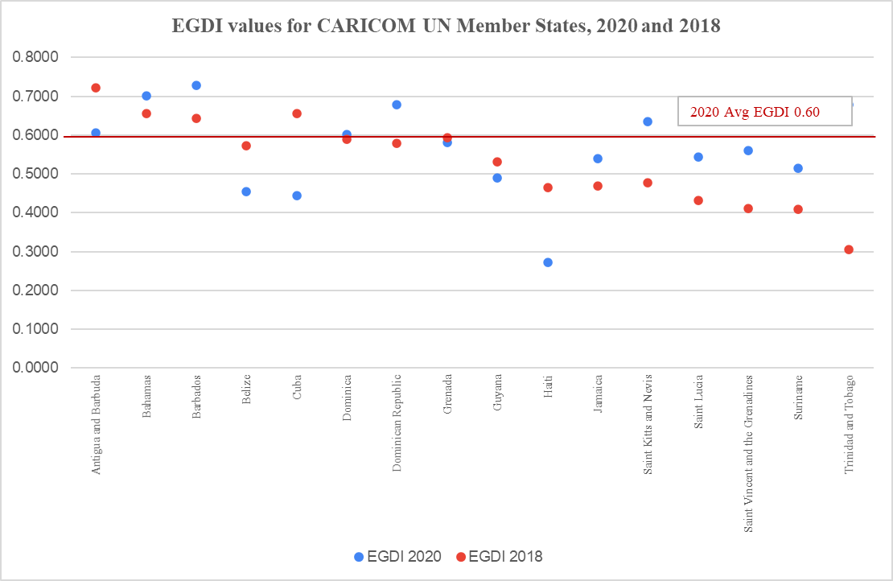
The Figure 2 presents the EGDI and sub-indices values for the 16 CARICOM countries for 2020, as well as EGDI values for 2018 (the dotted line). Majority (10 of 16) of these countries have improved their overall EGDI values, even if the overall EGDI ranking position among 193 UN Member States in 2020 may have declined. Hence, it is important to analyze the survey findings in the context of overall e-government development globally. The figure also illustrates that the human capital in the region (expressed by HCI) allows for faster e-government development, but poorly developed infrastructure (expressed by TII) continues to hinder the progress.
All these countries are Small Island Developing States (SIDS) and share similar capacity constraints experienced as a consequence of their small size, remoteness and dispersion (in the case of island archipelagos) and the impact of those constraints on the quality of the public sector. Nevertheless, as illustrated in the 2020 E-Government Survey (Box 2.7, page 60), the SIDS in the Americas tend to have higher EGDI values compared to SIDS in Oceania. For instance, 7 countries in the Caribbean score higher than the global average, including Barbados (0.7279), Bahamas (0.7017), Trinidad and Tobago (0.6785), Dominican Republic (0.6782), Saint Kits and Navis (0.6352), Antigua and Barbuda (0.6055) and Dominica (0.6013).
While the use of social media by government agencies tends to be more limited or restricted in the SIDS in Oceania and must be approved, in part due to bandwidth connectivity issues in public institutions, most public institutions in the Caribbean freely promote events, disseminate information and engage with citizens through social media outlets.
All but two SIDS in the Americas have national strategies on e-government/digital readiness in place, and these strategies often address the adoption of frontier technologies such as the Internet of Things, virtual reality, augmented reality, smart cities, big data and blockchain. In the strategies of the Dominican Republic and Trinidad and Tobago, attention is given to “once-only (data)” and “digital-first” principles in online services provision.
Figure 2: EGDI and sub-indices (OSI, TII and HCI) for CARICOM UN Member States
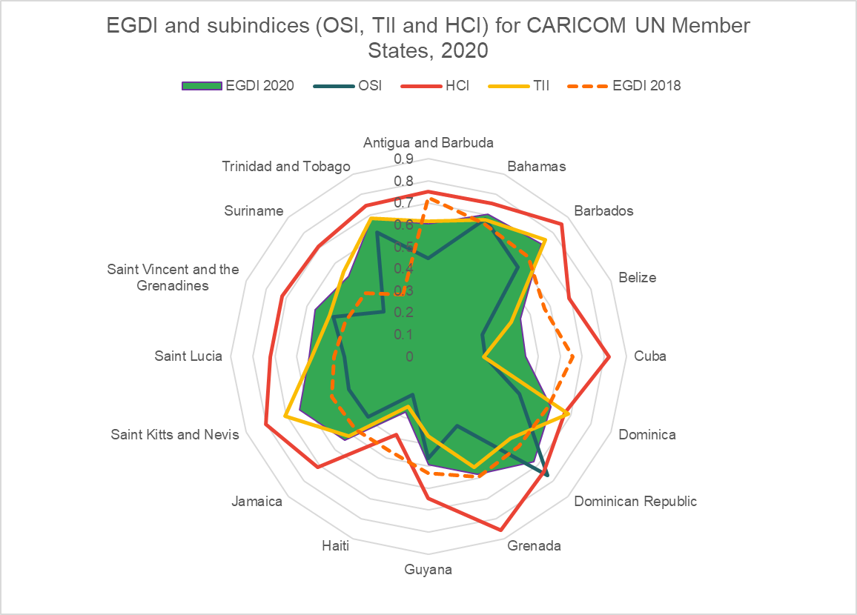
Caribbean SIDS are more likely than SIDS in Oceania to have digital implementation plans that make specific reference to e-participation, digital inclusion and/or public engagement, and many SIDS in the Americas, including the Dominican Republic, and Trinidad and Tobago, allocate government resources (a certain percentage of gross domestic product) for the improvement of ICT infrastructure in the public sector. Internet and ICT use among public officials in some Caribbean SIDS (e.g. in Saint Vincent and the Grenadines) is above 90 per cent.
Additional information about the survey and each country’s e-government development over the years can be found on E-Gov Database at https://publicadministration.un.org/egovkb.

Quartile is a statistical term describing a division of data into four defined intervals. The quartile measures the spread of values above and below the mean by dividing the distribution of data into four groups. A quartile divides data into three points—a lower quartile, median, and upper quartile—to form four groups of the data set. In the 2020 United Nations E-Government Survey, the lower (or first) quartile in each EGDI group is denoted as L1, M1, H1 or V1 and is the middle number that falls between the smallest value of the data set and the median. The second quartile (L2, M2, H2 or V2) is also the median. The upper (or third) quartile, denoted as L3, M3, H3 or V3, is the central point that lies between the median and the highest number of the distribution. LM, MH, HV and VH are the highest data points in each EGDI group.

